 | B.M.S. COLLEGE OF ENGINEERING, BANGALORE-19  Computer Science & Engineering
INTERNALS-1
Course Code: 23CS4PCADA |  | Course Title: Analysis and Design of Algorithms
Semester: 4 |  | Maximum Marks: 40 | Date: 28-03-2025
Faculty Handling the Course: |  | Dr. JSN, Dr. KPM, SDV, NM, Dr. SG, VBM
Instructions: Internal choice provided in Part C.

PART-A
Total 5 Marks (No Choice)
No. | Question | Marks | CO-PO
1 | Apply Master’s theorem to solve the following:  T(n)=5T(n/2) + n | 5 | 1-1

PART-B
Total 15 Marks (No Choice)

No. | Question | Marks | CO-PO
2 a) | Consider function 1 and function 2 expressed in pseudocode as follows:  function_1 function_2  while n>1 do for x=1 to n do x=x+1 end for n=n/2 end while for x=1 to 100*n do x=x+1 end for  Let f1(n) and f2(n) denote the number of times the statement “x=x+1” is executed in Function 1 and Function 2 respectively.  - f1(n) = Ω(f2(n))  - f1(n) = O(f2(n))  - f1(n) = Ɵ(f2(n))  Justify which of the above option is correct. | 5 | 2-2
2 b) | Write an algorithm to add first n natural numbers and derive the time complexity for the same. | 5 | 2-2
2 c) | Analyze how multiplication of two long integers is better using Divide and Conquer technique compared to conventional multiplication. Demonstrate the same with an example. | 5 | 2-2

PART- C
Total 20 Marks

No. | Question | Marks | CO-PO
3 a) | The graph shown below represents nodes as cities and edges as the cost of visiting from one city to another. The path cost of travelling from one city to another is decided by the traffic along that route and the possible routes from the city are visible once you reach the city. Design an autonomous driving vehicle which has to visit all the cities without repeating any of the cities with a minimum cost. The starting city can be any arbitrary city.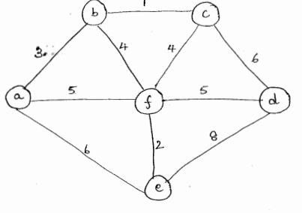 | 10 | 1-1
 | OR
3 b) | The following are the relative access times of the files with respect to the day on which they have to be sorted. Apply Quick sort algorithm to show the sequence after every iteration and also the final sorted array for the following numbers:  100, 13, -51, 145, -167, 89, 131, -11, 56, 78  Derive the worst case and best-case time complexity to do the sorting. | 10 | 1-1
4a) | - Apply Kruskal’s algorithm to find the t Minimum Spanning Tree of the following graph.  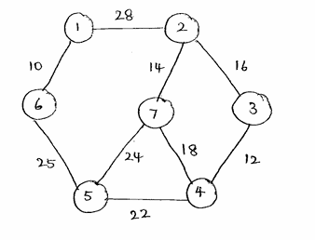  - Consider the following functions:  f(n)=2^{n}  g(n)=n!  h(n)=n^{log2n}  Sort the above functions in decreasing order of asymptotic growth rate and justify. | 10 | 1-1  2-2
 | OR
4b) | - Apply Merge sort algorithm for the following numbers to sort in descending order:  234, 123, 451, 678, 987, 128, 111, 91, 76, 34, 21  - Consider the following functions:  f(n)=$√n$  g(n)=n log n  h(n)=10  Sort the above functions in increasing order of asymptotic growth rate and justify. | 10 | 1-1  2-2

***ALL THE BEST***

